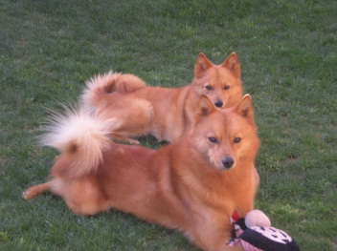
Skandia Finnish Spitz Glendale,AZ 623-572-6916
Peggy L. Urton skandiafinnishspitz.com skandia@aol.com

Questionnaire for prospective puppy owners Date: _____________________________
1. | Your name:  Home Address:  Phone Number:  E-mail address: | ___________________________________________________  ___________________________________________________  ___________________________________________________  ___________________________________________________  ___________________________________________________
2. | Are you interested in a puppy or an older dog/rescue? | ___________________________________________________  ___________________________________________________
3. | Do you prefer a male or a female? Why? | ___________________________________________________  ___________________________________________________
4. | List current members of your household. If there are children, what are their ages? | ___________________________________________________  ___________________________________________________  ___________________________________________________
5. | List previous dogs owned. Why are they no longer with you? | ___________________________________________________  ___________________________________________________
6. | List current dogs owned. Include age and sex. | ___________________________________________________  ___________________________________________________
7. | List other pets in house. Include age and sex. | ___________________________________________________  ___________________________________________________
8. | Who will be the primary caregiver for the puppy? (walks, feeding, training, etc.) | ___________________________________________________  ___________________________________________________
9. | What made you choose a Finnish Spitz? | ___________________________________________________  ___________________________________________________
10. | Where will your puppy stay during the day? At night? | ___________________________________________________  ___________________________________________________
11. | How do you plan to exercise your Finnish Spitz? | ___________________________________________________  ___________________________________________________
12. | Will someone be home with the puppy during the day? If yes, who? If no, how many hours will he/she be home alone? | ___________________________________________________  ___________________________________________________  ___________________________________________________
13. | Have you ever raised a puppy before? If yes, what breed? | ___________________________________________________  ___________________________________________________
14. | What activities/training are you interested in doing with your Finnish Spitz? (showing, agility, obedience, rally, hiking, therapy, etc.) | ___________________________________________________  ___________________________________________________  ___________________________________________________
15. | Do you have a veterinarian? | ___________________________________________________
16. | Do you own your own home? | ___________________________________________________
17. | Do you have a fenced yard? | ___________________________________________________
18. | How long are you willing to wait for a puppy? | ___________________________________________________  ___________________________________________________
19. | How did you find me? | ___________________________________________________  ___________________________________________________

